Therapeutic Massage by Lounette

Phone: What’s App: 1-242-827-4093

Or call directly: 1-242-827-4093

Email: [Lounette1on1@gmail.com](mailto:Lounette1on1@gmail.com)

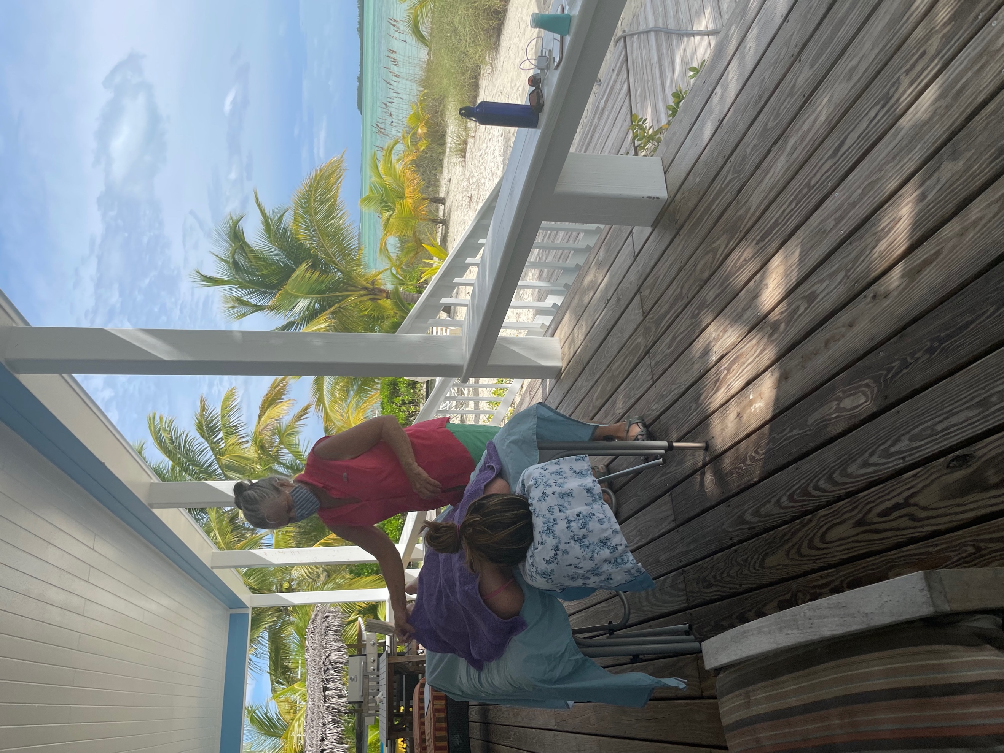­­­ ­

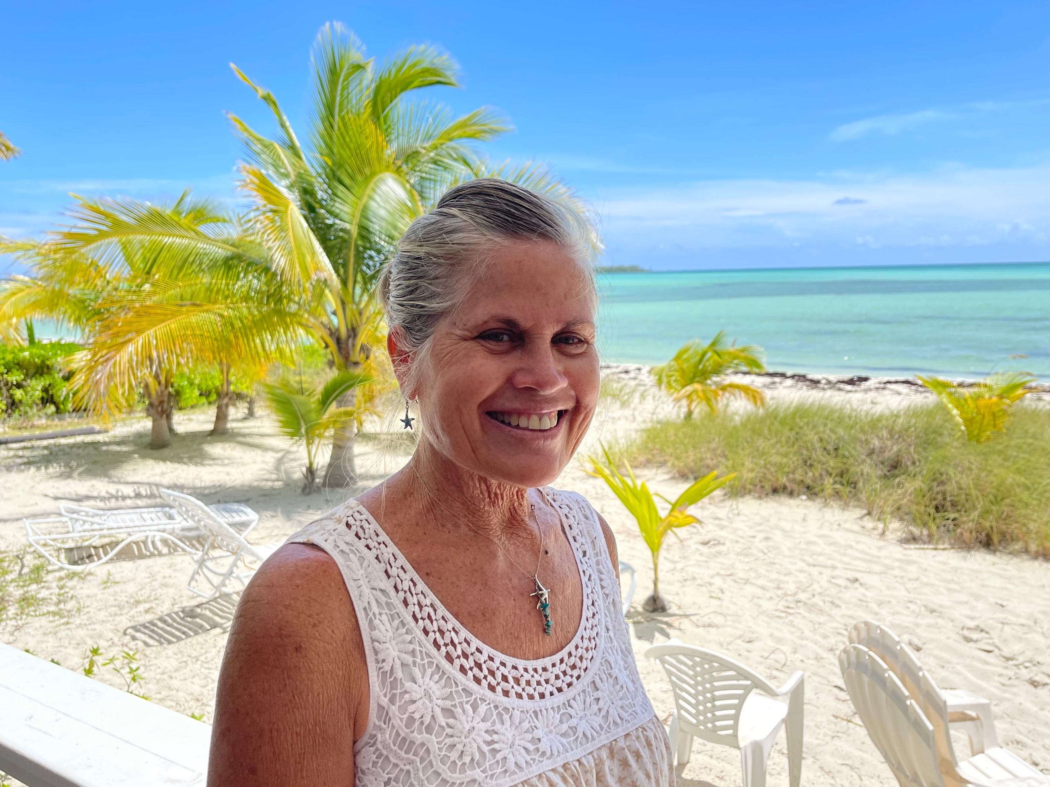

Call or email for details.