**Bonefishing The Beach at Casuarina Point, Abaco Bahamas**

Document Updated: 1/1/2023

Instructions for fishing the beach in front of Abacobeachrentals.com, Bon Ami and Abacopalms.com

Welcome! Many people come here to fly fish for the elusive gray ghost of the flats (better known as the Bonefish). This tutorial is written for anglers who are fishing the surf/beach in the winter using a light tackle casting rod with bait. *While these instructions are targeted to anglers with a fair amount of fishing knowledge, less experienced anglers with no idea of what some of this stuff is can follow the same basic diagram for a spinning rod using basic monofilament line.*

The tackle shops in Abaco typically carry only large offshore type fishing rods and reels, but sometimes they sell broken or used rods at Island Boy Tackle, they don’t sell light tackle equipment OR terminal tackle. And what is available tends to be very expensive--so bringing your own rods, lines, hardware, hooks, weights, etc. is the best policy.

The best setup for surf fishing the beach is light tackle spinning rods that break down for transport on an airplane. Here is what I use:

**The Rod**

Use a rod that breaks down into 3 pieces so it can fit in your “checked” luggage. I find that a duffle bag on wheels works best and can fit a lot of stuff! Be sure that it does not exceed 50 pounds for the airplane, as they will weigh it. The rod should be a simple spinning rod 6.5 to 7.5 feet and a 3000 series or bigger reel.

**The Reel, Line, and Terminal Tackle**

A good spinning reel is capable of holding at least 200 yards of line for the long bonefish runs. I prefer 10-lb braid filled to within 1/8” of the reel arbor.

I use braided line versus monofilament because the diameter of the braid is smaller than the mono at the equivalent weight using 10-pound test so you can fit a lot more line on the reel arbor.

Tied to the end of the braid is a piece of 20-lb monofilament leader: a good choice is Trilene Big Game mono. These bonefish do not appear to be leader shy so there’s no need to use fluorocarbon with the added expense. I tie a piece of 2‑foot mono to the braid using a double uni knot This is a strong knot.

To the monofilament line I add in this order: A sliding braid fishfinder rig that has a weight holder, a bead (the bead is there to prevent the weight from wearing down your knot) and then a uni-knot tied to a black two-way swivel. 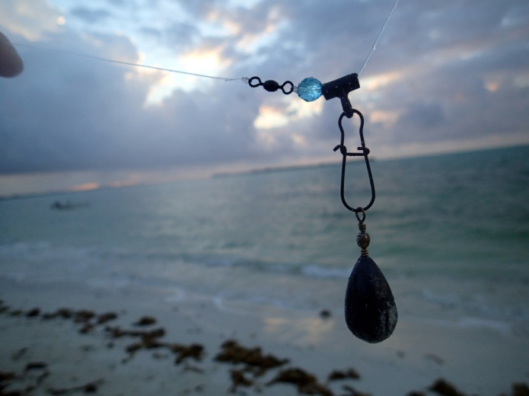To the other end of the swivel I tie on an 18” piece of 20-lb test mono line with another uni-knot to the swivel and then a sharp #4 hook on the end of the mono. Sometimes I use circle or octopus hooks with a light drag setting.

**Beach Fishing Rig in Full Detail**.

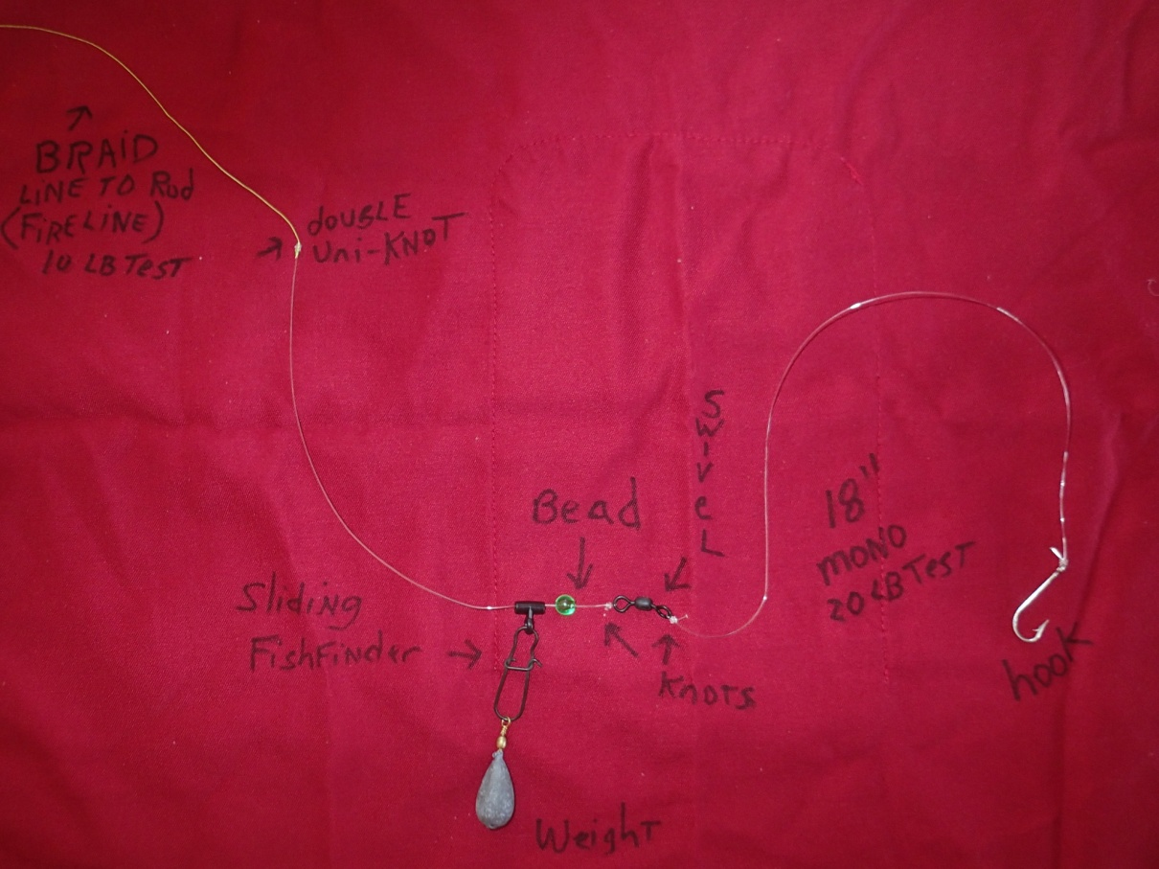

**Weights and Swivels**

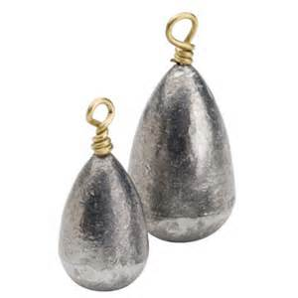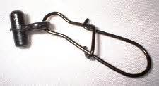You will need to put a weight on the sliding fishfinder rig. Determining the weight size requires experimentation on your own with the tides/current/wind. You want to keep a fairly taut line out in the water but some slack is OK too. Weight sizes ¾ ounce to 2 ounces work well. It is best practice to use the weights with the brass swivel on top. The brass swivel weights fit better on the fishfinder rig and work better than straight lead weights. Use the small size braid-ready sliding fishfinder rigs for less tangle on the ocean floor.

**Drag**

Do not set the drag on your reel too tight or too loose; the first run a bonefish makes will be fast and furious so you want to let him speed away and a too tight drag may interrupt that flight.

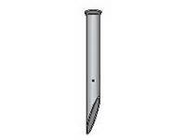**Sand Spikes**

Sand spikes for holding your rods in the beach sand need not be large, but must be dug into the sand pretty deeply, because when you least expect it, a bonefish will grab your bait and your rod with it and you may have to go swimming if your sand spikes are not pounded deep into the sand!

**The Bait**

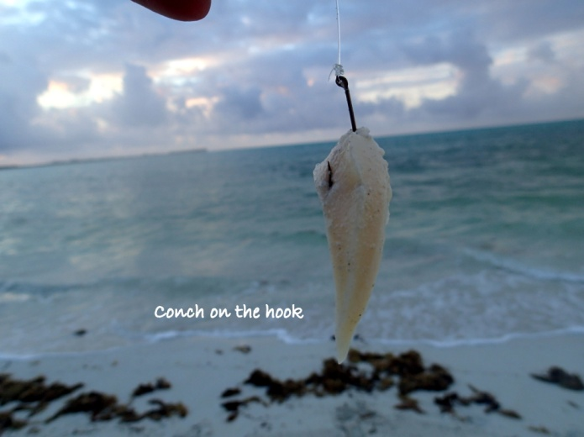Do not use a baitholder hook, it will be too difficult to catch and release the bonefish. On the hook you will put some conch bait, cut up into little pennant style pieces. Shrimp also works, but falls off the hook too easily and conch lasts a lot longer. A&A Seafood sells the conch. Buy the large sized conch chunks and cut up yourself. The conch that they sell cutup is pre-tenderized and falls off the hook too quickly.

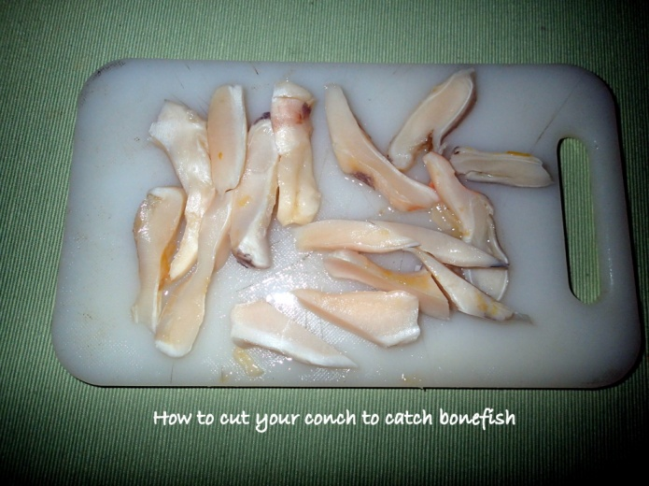Do not leave the conch in the refrigerator or it will get too mushy. Cutup and freeze in separate bags about 10 pieces in each bag and take with you to the beach. Just pour a little warm water into the bag to unfreeze.

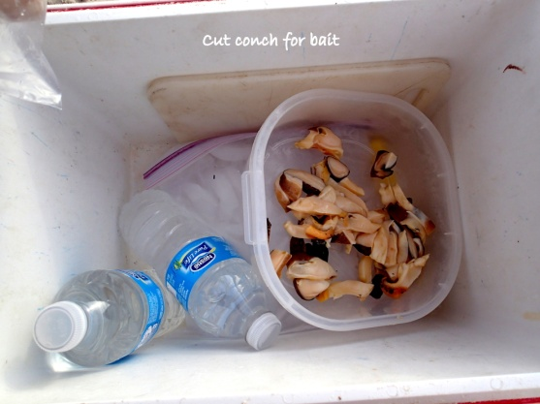Fresher always seems to work better. Keep your bait on top of ice in a Tupperware container in a cooler with a rag and close the cooler or the flies will get to it. You will want to check your bait every 10 to 15 minutes after not getting a bite as some fish are very clever in removing the bait without your knowledge.

**Tides**

The closest tide chart can be found at Pelican Harbor on line. This is a very worthy piece of paper that you need to pay attention to! We have caught most of our bonefish on the rising tide at the beach to near high tide, when the bonefish cruise the beach. Sometimes they will swim right past your ankles. When the tide is farther out, about 2 to 3 hours before high tide, cast far, when it’s nearly high tide, cast closer in. The time of day doesn’t seem to matter a whole bunch, but in the winter when the water has had a chance to warm throughout the day, and the warmer water is in the later afternoon, this is generally a good bet.

At low tide, it’s always fun to attach your rod to a kayak using some bungee cords, pack a little lunch, and take off to the big sand bar to the east side of the beach. Paddle out there, pull your kayak onto the sandbar and walk out to the farthest point. Over the east side of the bar is a deeper trench that is a channel for fish to cruise around in and you can stand on the sand and cast into the deeper channel. Here you may find mutton snapper, some reef fish like triggerfish that cruise through, and grey snappers, palometas, and other fish. This same rod/rig setup that you use on the beach is good for this channel fishing too! I would change to a heavier leader and a much heavier weight up to 4 ounces as the current is very swift there. There are also bonefish travelling around that area at low tide as well. Big rays will leap out of the water and crash down, spectacular to watch. You will get hung up on the artificial reef, there. Bring a change of hardware.

**Weather/Wind**

I have not determined that the wind going against the tide or with the tide makes a difference here at the beach surf, I have caught fish at both times. However, if there is a big SOUTH wind front carrying seagrass onto the beach or a cold snap, don’t fish or you will get lots of weeds. It takes about 2 days for the water to return to normal where you can catch bonefish again. I do not yet have a handle on best water temps for catching bonefish, but a general trend is that warmer is better.

**Fishing (and Catching)**

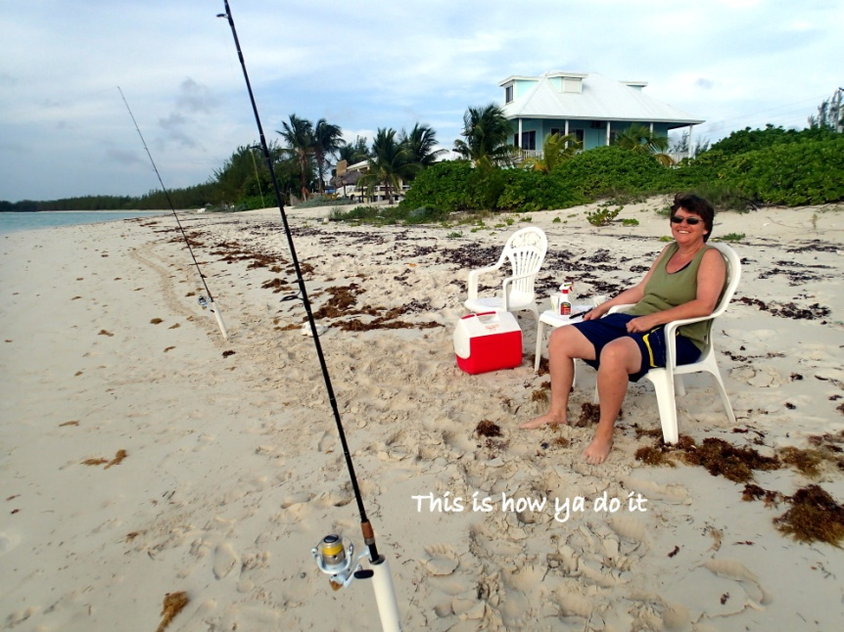You probably won’t see anyone else fishing the beach with a spinning rod, but it is a fun pastime when you bring your cooler, your chairs, a little table, some cold drinks, and throw your line out. The weight is used on the surf beach to allow you to cast out into the water and to keep the tide from washing your bait right back up on the beach.

Remember to dig the sandspike rodholders into the sand deep! You can go with a simpler setup using a sliding weight without the sliding fishfinder but when the wind picks up, you often need to change the weight so the fishfinder rig is easier. I notice that the smaller bonefish will run towards you at the beach so you need to reel fast to keep the line from going slack. The bigger fish seem to want to take off to sea, so let them go while they’re taking line and then start reeling them in when they let up a little. A bigger bonefish will make several runs. Try to guide them away from the boat moorings to avoid getting hung up.

Cast into clear areas of water, close to the turtlegrass/weed patches. Small crustaceans are in there and the bonefish use that for cover from predators to cruise around in. If you get stuck in a weed patch, wiggle it out, check your bait and recast.

Sometimes, it pays to reel your bait slowly in once you cast it far out in the water. One revolution of the reel handle in about 10 seconds moves the bait just enough that a bonefish can pounce on it. Sometimes when you reel closer into the beach, little fish will start playing with your bait and tugging on it but can’t get their mouth around the hook. So, although it can be frustrating, don’t give up. Sometimes a bonefish will cruise through, see the little fish on the bait which triggers a competitive fury in the bonefish who will then snap up on the bait, giving you a run for the money. Or, you can just let your bait sit there, but when crabs are around, they will certainly start chewing on it.

Night Fishing requires headlamps and several snappers can be caught off the beach about 2.5 hours before high tide. Squid works good for snappers. I use octopus or circle hooks with a loose drag and a clip on light stick snapped on the tip of the rod. This will alert you to a bite! You can order them on Amazon and they last a very long time. Be sure you get the right size for the tip of your rod so that the lightstick snaps on tight.

<https://www.amazon.com/thkfish-Fishing-Glow-Sticks-20pcs%EF%BC%8810bags/dp/B07FDP8H42/ref=sr_1_36?crid=38STD4YAF3972&keywords=light%2Bsticks%2Bfor%2Bfishing&qid=1671099980&sprefix=light%2Bsticks%2Bfor%2Bfishing%2Caps%2C116&sr=8-36&th=1>

**The Payoff!**

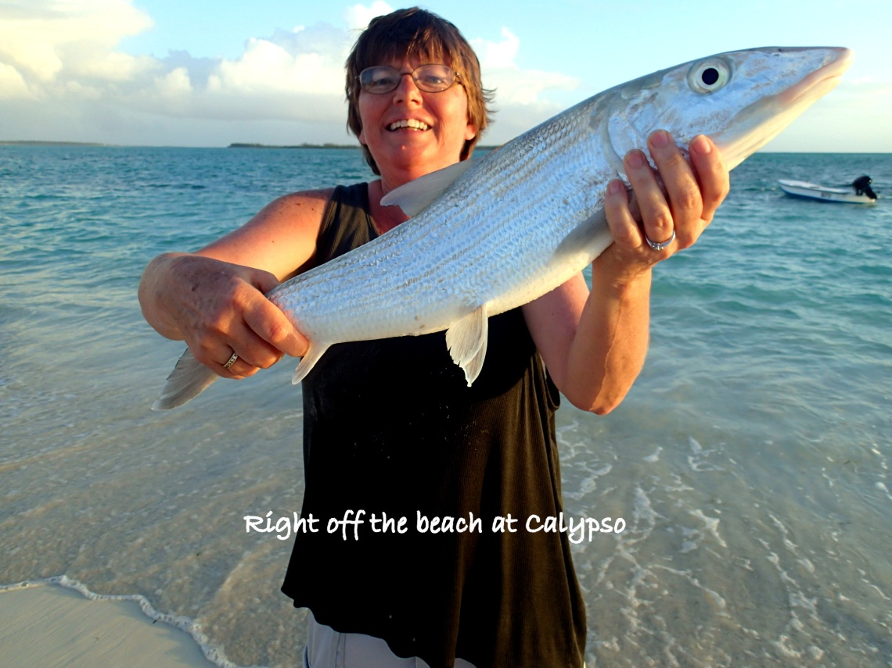

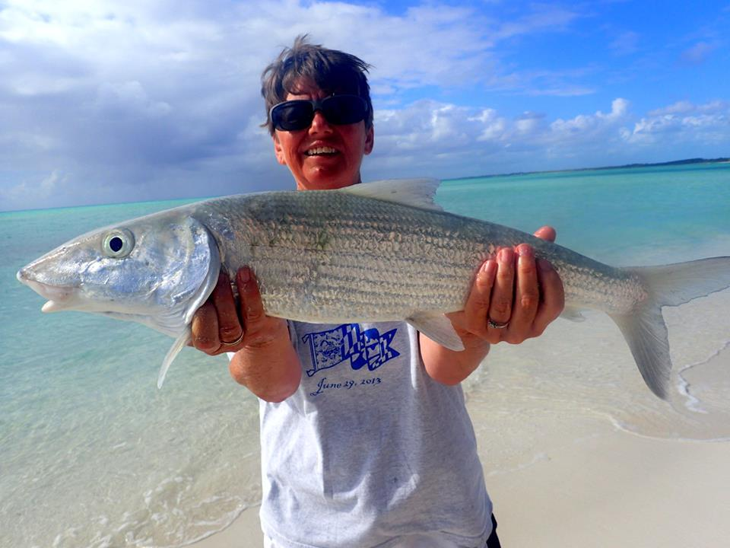

In front of the cottages at Abacobeachrentals.com

Any questions please feel free to contact me at: [lisadoricchi@gmail.com](mailto:lisadoricchi@gmail.com)

Good Luck!